AWS Fraud Detector –
Magento Admin User Guide

To configure the Transom – Amazon Fraud Protection extension go to Stores > Configuration > Sales > Trust and Safety

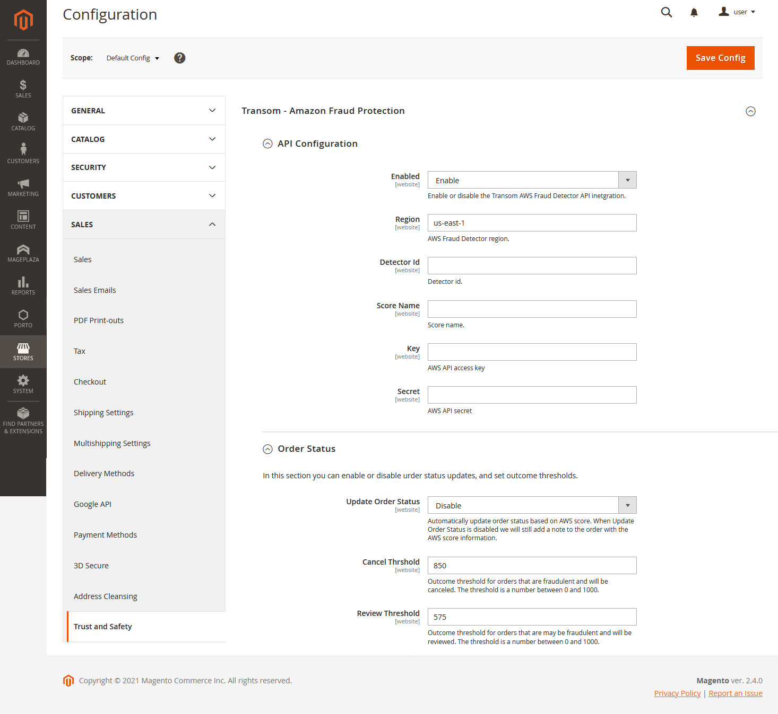

API Configuration
API configuration settings marked with * depend on settings that are managed by the Amazon Fraud Detector system administrator.

Enabled
Enable or disable the Transom Amazon Fraud Detector integration.

Region *
The AWS region where the Amazon Fraud Detector Model is being hosted.

Detector Id *
The AWS detector id we have configured in the AWS console.

Score Name *
The AWS outcome score name for the Model we have configured in the AWS console.

Key *
The AWS IAM key we set up in the AWS console.

Secret *
The AWS IAM secret we set up in the AWS console.

Order Status

Order Status Update
Enable or disable automatic order status update.

When Update Order Status is enabled, we will add a note to the order and automatically update order status based on model outcome score.

When Update Order Status is disabled, we will still add a note to the order with the model outcome score information.

Cancel Threshold
Model outcome threshold for orders that are fraudulent and will be canceled. The threshold is a number between 0 and 1000.

Review Threshold
Model outcome threshold for orders that may be fraudulent and will be reviewed. The threshold is a number between 0 and 1000.

